**Leader Overview**

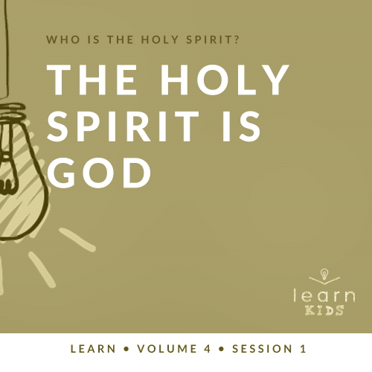

**Volume Overview**

**Who is the Holy Spirit?**

*In His most famous sermon (*[*Matthew 5–7*](https://ref.ly/logosref/Bible.Mt5-7)*), Jesus taught us to love our enemies, give to the needy, and put God’s kingdom first in our life. These high expectations don’t take us long to recognize a problem. We simply can’t do this on our own. So, why did Jesus command us to live a life He knows full well we cannot live on our own? The key is that Jesus never asked us to live the Christian life on our own. In fact, Jesus explained there is a gift that is indispensable for every Christian: the Holy Spirit. Jesus as God in the flesh is a wonderful gift, and God living inside us is amazing too! God living within us can empower us, help us grow, and equip us in a unique way that God among us could not*.

**Session Overview**

**The Holy Spirit Is God**

*The Book of Acts begins with some wonderful events. The Holy Spirit baptizes Jesus’ followers on the Day of Pentecost. His work transitions from just dwelling in believers to filling them with power to radically change the world for Jesus. The Church is growing and people are being healed. Then, we find this challenging story about two believers who decide to lie to church leaders, but discover they really lied to the Holy Spirit. The consequences seem harsh, but it’s a confirmation to us that the Holy Spirit is God. We must treat Him with the honor and respect He deserves*.

**Bible Lesson**

Ananias and Sapphira Lie to the Holy Spirit

[Acts 5:1–8](https://ref.ly/logosref/Bible.Ac5.1-8)

**Faith Fact**

The Holy Spirit lives in me.

**Faith Verse**

[Galatians 5:22–23](https://ref.ly/logosref/Bible.Ga5.22-23) (NLT)

The Holy Spirit produces this kind of fruit in our lives: love, joy, peace, patience, kindness, goodness, faithfulness, gentleness, and self-control.

**Preparing for the Session**

**Leader Preparation Time: 20–25 Minutes**

|  |
| --- |
| ***You Will Need***  ***Large Group***   * *Bible* * *Worship songs (Song suggestions: “Holy Spirit” by Kari Jobe; “Set a Fire” by Jesus Culture; “Come Holy Spirit” by Vertical Worship; “Zeal” by The Belonging Co)* * *For groups not using a phone or tablet only, add:*   *• Projector or TV*  *• Laptop*  *•* ***Faith Fact Slide***  ***• Faith Verse Video*** *or* ***Slide***  *•* ***Bible Lesson Video***  *•* ***Teaching Point Slides 1–3***  *• Broken dish, glass, or keepsake*  *• Phone*  *• Picture of a stoplight*  ***Small Group***   * ***Small Group Group Connection Page****, one per group* * *Small container* * *Scissors* * *Bibles for kids in your group to share* * ***Small Group Faith Verse Review****, one set per group* * *Card stock* * *Scissors* * ***Small Group Activity Page****, one per kid* * *Pencils or pens, one per kid*   *To access session content and videos from a computer, visit:* [*BibleEngagementProject.com/downloads*](https://bibleengagementproject.com/downloads) |
| ***Getting Ready***  ***Large Group***   * *Download videos and slides if needed.* * *Select worship song(s) and have them ready to play.* * *Read the Bible Lesson Scripture to prepare for teaching time.*   ***Small Group***   * *Print the* ***Small Group Connection Page****, one per group.* * *Cut apart the slips and place them in the small container.* * *Print the* ***Small Group Faith Verse Review*** *on card stock, one set per group.* * *Cut apart the cards on the* ***Small Group Faith Verse Review****.* * *Print copies of the* ***Small Group Activity Page****, one per kid.*   ***First time leading* Learn *for Kids? Check out the*** [***Facilitator Guide***](https://0b769b0ed3569ef9d18b-f88d8272f61086866d50d048b43ef630.ssl.cf2.rackcdn.com/sites/biblengagementproject/Listen_Facilitator_Guide.pdf)***.*** |

**Large Group**

**30 Minutes**

*See what’s needed at the beginning of the session.*

**Introduction**

It’s time to answer a big question. Who’s ready? *(Group response)* I hope you’re ready because I will definitely need your help with answering this question. Do you want to know what it is? *(Group response)* Who is the Holy Spirit? How would you answer that question right now? *(Allow responses.)* Those were all great answers. There isn’t just one right answer to our big question.

The main thing we’ll focus on today is that the Holy Spirit is God. Did you know that? *(Group response)* Our one God showed himself to us in three Persons who have always been—the Father, Jesus, and the Holy Spirit. The Bible story we’ll hear today helps us know that the Holy Spirit is God, just like God the Father and Jesus the Son.

**Faith Fact**

One of the best things about the Holy Spirit is found in our Faith Fact today: **The Holy Spirit lives in me**. If you’ve decided to follow Jesus, our Faith Fact is true about you, too.

• *Show the* ***Faith Fact Slide***.

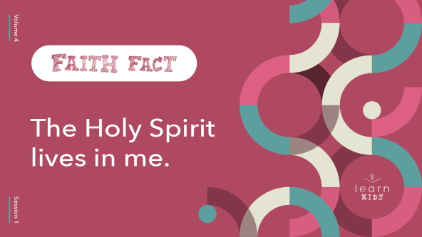

Can you say that with me one more time? **The Holy Spirit lives in me**. Now put both hands over your heart and say it again. **The Holy Spirit lives in me**. Great job!

**Game**

**Eye Contact**

We can’t see the Holy Spirit and most of the time we can’t hear Him out loud, but He still lives inside us when we’ve invited Jesus into our life and heart, and asked Him to forgive our sins. The Holy Spirit gives us direction for our life.

We’re going to play a game where you need to watch carefully for directions. I’ll start by pointing to one person and motioning for them to move someplace in room. I’ll give a thumbs-up if they followed my instructions carefully. Then, that person will quickly choose someone and motion to where they need to move. We’ll keep playing until everyone has moved to a new spot.

• *Play the game until everyone is standing around the room*.

Did you notice that we had to watch and pay attention to know what to do and where to go? That’s what we need to do with the Holy Spirit, too. Because He lives in us, He’ll lead us if we let Him. You had to practice patience to wait your turn. Patience is something the Holy Spirit helps to grow in us. I’m so thankful God the Father gave us the Holy Spirit.

• *Consider letting the kids stay standing around the room for worship*.

**Worship**

As we worship today, let’s celebrate that the Holy Spirit is living inside us. Let’s sing now as we worship God.

• *Lead the kids in singing one or two praise songs. See suggestions at the beginning of the session*.

**Bible Lesson**

I’m sure God loved hearing us worship today. I hope you brought your Bible and are ready to hear a shocking but true Bible story today. Now that I have your attention, let’s take a moment to focus our attention on God and pray before we hear from His Word.

**Prayer**

|  |
| --- |
| *Dear God, thank You for teaching us about the Holy Spirit in Your Word. Help us to honor and respect You in what we say and do. Amen.* |

**Video Intro**

Just before we look at the Bible story, let’s watch this video.

• *Play* ***Bible Lesson Video***.

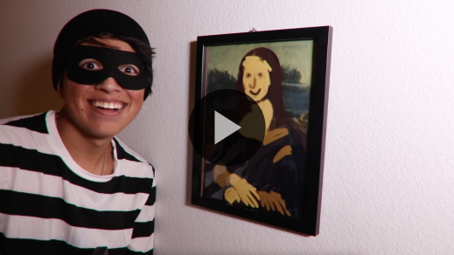

**Bible Story**

**Ananias and Sapphira Lie to the Holy Spirit**

That video was a great lead-in to our Bible story today and helps us understand the Faith Fact. Say it with me. **The Holy Spirit lives in me**. What happens to the couple in our Bible story today is pretty extreme. Let’s read about it. Grab your Bible or pull up a Bible app on your device. Turn to [Acts 5:1–8](https://ref.ly/logosref/Bible.Ac5.1-8).

• *Read the Bible story aloud to the group*.

• *In order to keep Large Group time moving along, we don’t recommend having the kids read*.

• *Optional: Remind the kids to mark this place with their Bible Bookmark, so they can read it on their own at home*.

**Teaching Time**

|  |
| --- |
| ***You Will Need***   * *Broken dish, glass, or keepsake* * *Phone* * *Picture of a stoplight*   *No prep needed for this activity.* |

Can you believe that Ananias and Sapphira just dropped dead? *(Group response)* It’s a little scary to be honest. Thankfully, God doesn’t typically handle things that way when we do something wrong like they did. Their story is an example of what not to do. Let’s look at what it teaches us about the Holy Spirit.

**1. The Holy Spirit is God**.

• *Show the* ***Teaching Point 1 Slide***.

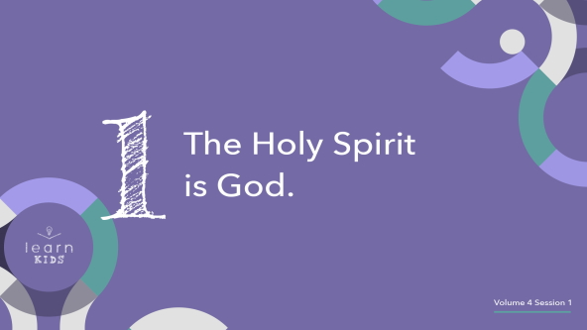

The Holy Spirit is God, and He knows everything. Remember God is one God in three Persons. Can anyone remember who they are? *(Allow responses.)* There is God the Father, Jesus the Son, and the Holy Spirit. They are all God. When we talk to God, we should be truthful because God knows everything.

Ananias and Sapphira thought they could lie and hide something from the church leaders. They thought they could get by with it, but they were very wrong. Have you ever done something wrong and tried to cover it up? *(Group response)*

Imagine you accidentally broke one of your mom’s favorite things.

• *Hold up a broken dish*.

Would you be tempted to hide what you did? *(Group response)* You could dig a hole in your backyard, put the broken pieces in the hole, and bury it. You might have literally hidden the evidence.

Here’s the thing: You might be able to lie or get away with hiding something from a parent, teacher, or friend like Ananias and Sapphira thought they could do.

But the Holy Spirit sees everything you do, and He hears everything you say. That can be a comforting and encouraging truth, or it might make you uncomfortable and feel guilty if you’re trying to hide something. If you feel uncomfortable or guilty when you hear that God is always around, you may have some things in your life that you need to change. You may need to ask God to forgive you.

**2. The Holy Spirit lives in me**.

• *Show the* ***Teaching Point 2 Slide***.

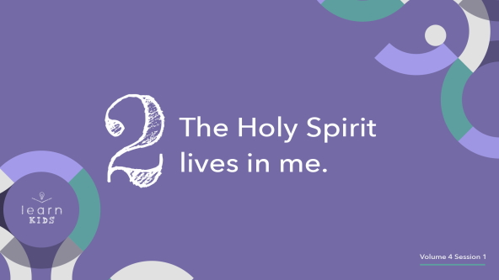

The Holy Spirit lives inside every person who decides to follow Jesus. That’s what our Faith Fact says. Say it with me. **The Holy Spirit lives in me**. Great job! Think about that. God lives in us.

Do you want to hear something amazing? *(Group response)* We can not only talk to the Holy Spirit anytime and anywhere, but He also can speak to us. Peter knew Ananias was lying because the Holy Spirit told him. The Holy Spirit still speaks to people all the time, but we must be ready to listen for Him to speak. He told Peter about Ananias and Sapphira, and the Holy Spirit can speak to you as well.

• *Hold up a phone*.

We can call on the Holy Spirit at any time. We don’t have to wait for Him to call us back when He’s not busy or message us later. Although it may not always feel or seem that way, He’s always here. We may not always realize that He is speaking to us, but He can.

• *Show a picture of a stoplight*.

You may never hear the Holy Spirit speak to you out loud. Like a stoplight tells people when to stop and go, the Holy Spirit might tell you to go and do things, or say things that you never would have thought of on your own. He’ll also warn you or tell you to stop when you shouldn’t do things like lie, steal, or disobey your parents. Have you ever experienced something like that? *(Group response)* Listen to the Holy Spirit and follow His leading. The more you follow Him, the easier it will be to hear His voice and sense His direction in your life.

**3. My body is the temple of the Holy Spirit**.

• *Show the* ***Teaching Point 3 Slide***.

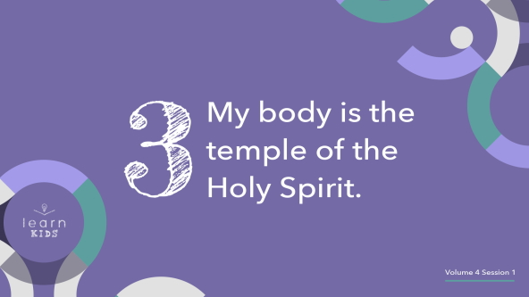

The Bible tells us that our body is the temple of the Holy Spirit. The story of Ananias and Sapphira shows us that we must honor the Holy Spirit inside us. We should treat our body well. We should aim to live a holy life because our body is the home of the Holy Spirit. God is living inside us. The Holy Spirit is our friend, but He must also be respected for who He is.

It’s very similar to the relationship many of you probably have with your parents, grandparents, or whoever takes care of you. Your parents love to hang out with you. Maybe you watch movies together, or they ask about how your day went. These things are things you would do with a friend.

Your parents are your friends, but they are also your authority figures who deserve your respect. They have been entrusted by God with raising you and taking care of you. When you disobey them, they have to correct you. God is like that, too. He wants to have a close relationship with us, but He is also our ultimate authority figure and deserves our respect.

**Prayer and Response**

*Consider playing a worship song softly in the background while kids pray*.

Let’s take a moment to really think about how incredible God is. He can live inside each one of us through the Holy Spirit. Our body is His temple. That’s an honor and privilege none of us deserve, but God loves us enough to make it true.

We only have the Holy Spirit living inside us because God sent Him to us. He is with us to help us, encourage us, guide us, and comfort us. Let’s take a few minutes to thank the Holy Spirit for living inside us and always being there for us.

**Prayer**

• *Optional: Have the kids repeat phrases of the prayer after you*.

|  |
| --- |
| Dear God, thank You for sending the Holy Spirit to live inside us. We need You to guide us through life. Help us learn to listen for Your voice. Amen. |

**Faith Verse**

Our Faith Verse tells us about some specific ways the Holy Spirit helps us. Let’s learn it together.

• *Play* ***Faith Verse Video***.

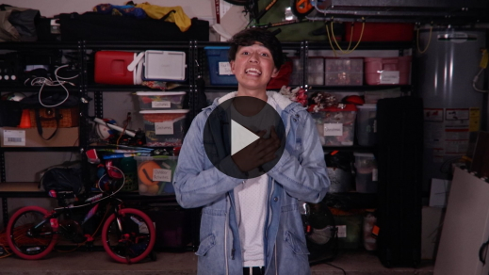

[Galatians 5:22–23](https://ref.ly/logosref/Bible.Ga5.22-23) (NLT)

The Holy Spirit produces this kind of fruit in our lives: love, joy, peace, patience, kindness, goodness, faithfulness, gentleness, and self-control.

Do any of you struggle with having any part of this fruit growing in your life? *(Group response)* I know I do. Most of us need to work on at least some of these in our life. The Holy Spirit will help us because He’s right here with us.

**Faith Fact**

That’s like our Faith Fact. Say it with me. **The Holy Spirit lives in me**.

• *Show the* ***Faith Fact Slide***.



Aren’t you thankful that we have access to the Holy Spirit and can talk to Him anytime? *(Group response)* I hope you never forget that and you choose to spend time with Him every day.

• *Dismiss kids to Small Group time or to go home if your group time ends here*.

**Small Group**

**30 Minutes**

*This section can be done in conjunction with the large group or on its own if you do small groups with your kids. During Small Group time, the goal is to connect the kids with the Word of God and to each other. All activities are led by the small group leader.*

**Group Connection**

**Hidden Talents**

|  |
| --- |
| ***You Will Need***   * ***Small Group Group Connection Page****, one per group* * *Small container* * *Scissors*   ***Getting Ready***   * *Print the* ***Small Group Group Connection Page****, one per group.* * *Cut apart the slips and place them in the small container.* |

All Christians have the Holy Spirit living in us. Our Faith Verse reminds us of the fruit the Holy Spirit grows in our life. We also have different talents and abilities that are given to us by God. Some of them may even be hidden talents no one else in our group knows about. We’re going to see what hidden talents are inside us just waiting to get out.

• *Hold up the container with the slips in it*.

I’ll draw a hidden talent out of this container. Then, I’d like at least two volunteers who think they have that talent to come up and show us what you can do.

• *Draw slips and let kids share their talents. Make sure everyone gets involved*.

• *Keep playing until you run out of slips*.

• *Optional: Allow the kids to come up with more hidden talents and challenges to share with the group*.

**Learn about It**

|  |
| --- |
| ***You Will Need***   * *Bibles for kids in your group to share*   *No prep needed for this activity.* |

**Scripture Search:** [**1 Corinthians 2:10–12**](https://ref.ly/logosref/Bible.1Co2.10-12)**;** [**1 Corinthians 6:19–20**](https://ref.ly/logosref/Bible.1Co6.19-20)**;** [**Ephesians 4:30–32**](https://ref.ly/logosref/Bible.Eph4.30-32)

Let’s dig deeper into God’s Word and see what else He has to say about the Holy Spirit as God. As we read each of these verses, let’s consider: What does this Scripture mean for our life today?

• *Give each kid a Bible and search for one or more of the Scriptures as a group together (as time allows). When everyone has found the Scripture, have one of the kids read it. Then answer the questions about it*.

• *Pair kids who need additional help with older kids or start simple and look up the session’s Bible story Scripture:* [*Acts 5:1–8*](https://ref.ly/logosref/Bible.Ac5.1-8)*. Kids will get better finding Scriptures the more they practice*.

• *Optional: Make this a competition to see who can find the Scripture first*.

**Bible Reading Tip**

When you’re reading your Bible, look for the different Persons of the Trinity: God the Father, Jesus, and the Holy Spirit. Notice the characteristics of each one and how they function separately and together. Our God is big and amazing. We’ll never fully understand Him and His ways, but we can get to know Him better.

**Challenge**

This week I want you to wake up every morning and pray something like this: Dear God, show me how Your Holy Spirit is working in my life today. Amen.

Then, I want you to pay attention as you go throughout your day and see if you notice the Holy Spirit speaking to you or guiding you. When you do, write it down either in a journal or on a piece of paper so that you can remember it.

**Faith Fact**

That’s like living out our Faith Fact. What is it? *(Group response)* Yes! **The Holy Spirit lives in me**. Say it with me again. **The Holy Spirit lives in me**.

**Group Discussion**

*Feel free to use all or just a few questions as a jumping-off place for good discussion. Questions marked with * are designed for more conversation. Adjust the questions based on the age or maturity of your group. Typically, older kids will be able to dive a little deeper than younger ones*.

**Questions**

• *If small group activities are not immediately following large group time, you may want to read the Bible story passage before this discussion*.

What did Ananias and Sapphira sell?

What did they do wrong?

How did Peter know what they had done?

Who did Peter say they lied to?

* What is one thing you know about the Holy Spirit?

* Why is it a good thing to have the Holy Spirit living inside you?

* What is something challenging about having the Holy Spirit around all the time?

* How can we take care of our body and treat it like it’s the temple of the Holy Spirit?

**Prayer Requests**

*Finish group discussion by sharing prayer requests and praise reports. Keep track of your small group’s prayer requests and review them each time you meet*.

**Prayer**

*Have kids pray for each other’s prayer requests*.

**Faith Verse Review**

|  |
| --- |
| ***You Will Need***   * ***Small Group Faith Verse Review****, one set per group* * *Card stock* * *Scissors*   ***Getting Ready***   * *Print the* ***Small Group Faith Verse Review*** *on card stock, one set per group.* * *Cut apart the cards on the* ***Small Group Faith Verse Review****.* |

Our Faith Verse is [Galatians 5:22–23](https://ref.ly/logosref/Bible.Ga5.22-23). It talks about one of the amazing things about having the Holy Spirit in our life. Let’s watch the Faith Verse video and do the actions for the verse together.

• *Show* ***Faith Verse Video***.



[Galatians 5:22–23](https://ref.ly/logosref/Bible.Ga5.22-23) (NLT)

The Holy Spirit produces this kind of fruit in our lives: love, joy, peace, patience, kindness, goodness, faithfulness, gentleness, and self-control.

**Faith Verse Fun**

**Fruit-Filled Phrases**

That’s a pretty long Faith Verse to learn. In fact, it’s two verses, but I know you can do it. Before we focus on trying to memorize our Faith Verse, I want to make sure you really understand it. The Faith Verse mentions the fruit that the Holy Spirit grows in our life. Let’s see how well we know what each part of that fruit really means.

• *Hold up the container with the fruit cards*.

You’ll draw a card with one part of the fruit of the Spirit. Your assignment is to use it in a sentence correctly. I’ll go first.

• *Let each kid draw a card and then use the fruit in a sentence. Help them out if they need it*.

• *Kids should return their card to the container*.

Now that we know more about what each part is, we’re going to play a game. You’ll need a partner. You’ll pick one of the fruit cards. Then, you need to act out a situation that shows that part of the fruit. The rest of us are going to see if we can guess what you are showing us. Any questions? *(Group response)*

• *Help kids pair up and choose a fruit card*.

• *Give kids time to practice their situations. Give them ideas if needed*.

• *Let the kids present their fruit situations to the group and have the other kids guess*.

You did a great job showing each other what the fruit of the Spirit is. I hope you’ll think all week about these things that the Holy Spirit wants to grow in us.

**Activity Page**

**Fruit of the Spirit Word Search**

|  |
| --- |
| ***You Will Need***   * ***Small Group Activity Page****, one per kid* * *Pencils or pens, one per kid*   ***Getting Ready***   * *Print copies of the* ***Small Group Activity Page****, one per kid.* |

Today, we’ll see how quickly you can find all of fruit of the Spirit in this puzzle.

• *Give each kid a* ***Small Group Activity Page*** *and a pencil*.

As you find each fruit, shout it out. Let’s go!

**Dismissal**

Remember, the Holy Spirit is always with you because He lives inside you. You can always count on Him because He is God.

**Prayer**

|  |
| --- |
| *Dear God, thank You for the Holy Spirit. Help us listen to the Holy Spirit as we grow closer to You. Amen.* |

**Faith Fact Recap**

• *Show the* ***Faith Fact Slide***.



One thing I want you to remember from today is our Faith Fact. Say it with me. **The Holy Spirit lives in me**. I can’t wait to learn more about the Holy Spirit with you next time!

• *Send home the* ***Small Group Activity Page***.

• *Remind parents that there are* ***Family Devotions*** *available on the app to do with their kid*.

• *Tell everyone the date and time for the next session*.